**REPORT**

|  |
| --- |
| **Experiment 1: LED Blink.** |

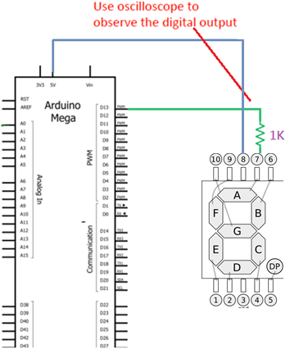

**NOTE: use DC coupling to observe the waveforms, and use measure to mark Vpp and frequency.**

1.

Arduino D13 output waveform with frequency 0.5Hz.

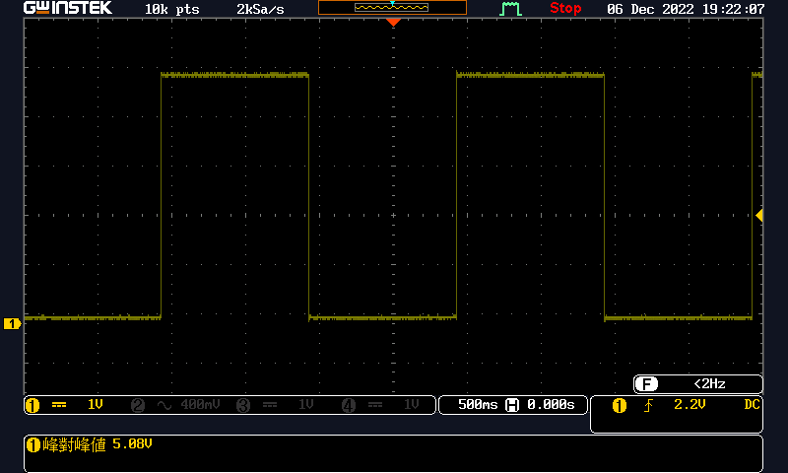

2.

Arduino D4 output waveform with frequency 1Hz.

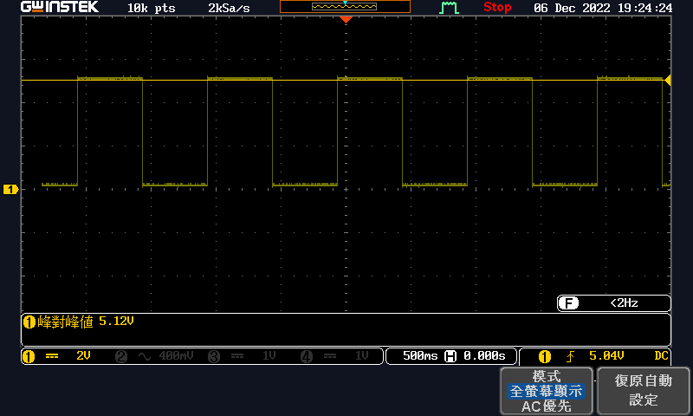

Question:

What output level (high/low) will make LED turn light or dark? Why?

High level will make LED turn light, and low level will make LED turn dark. High level means the LED

|  |
| --- |
| **Experiment 2: LED Blink with push button.** |

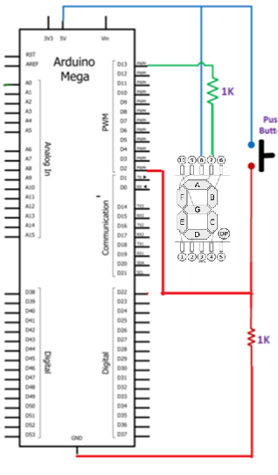

1.

Is this circuit a pull-high or pull-low type? _pull-low type_.

2.

Measure pin D2 voltage using voltage meter:

|  |  |
| --- | --- |
| Behavior | DC Voltage (V) |
| Pushbutton pressed | **5.12** |
| Pushbutton released | **0.08** |

3.

Change your circuit to another type and modify your code to achieve the same requirement.

Modified circuit (photo):

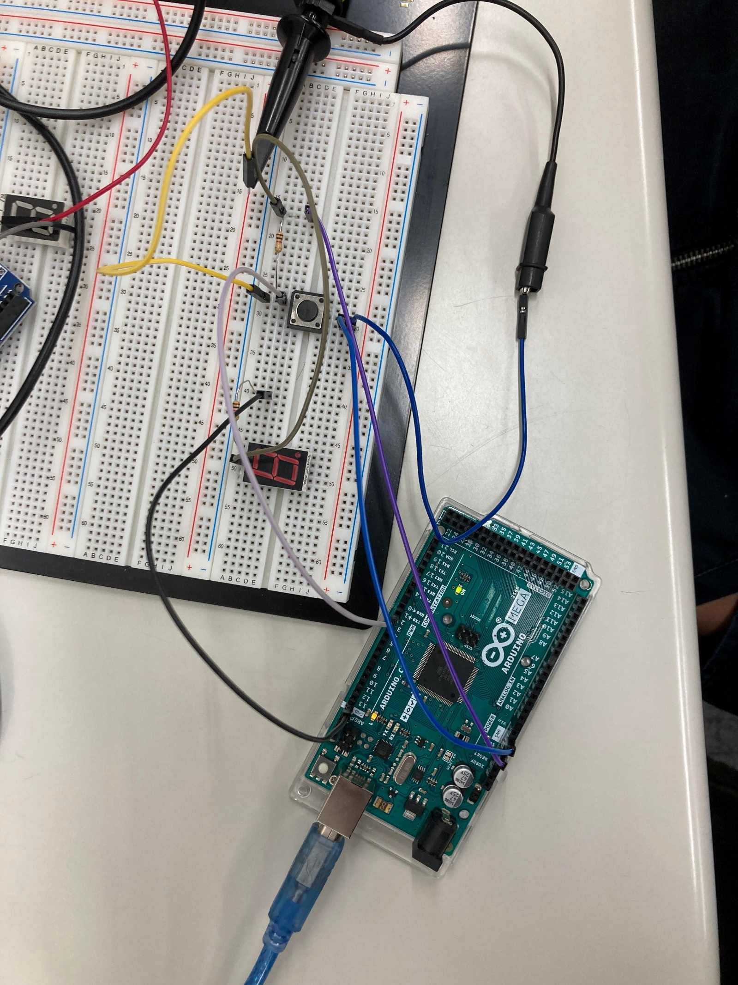

4.

Measure pin D2 voltage using voltage meter (the modified circuit):

|  |  |
| --- | --- |
| Behavior | DC Voltage (V) |
| Pushbutton pressed | **0.16** |
| Pushbutton released | **5.12** |

5.

Attach your modified code (screen shot):

*/\**

*\*This lab is to combine example 2 and example 3 in lecture to achieve following requirement.*

*\*When push-button is pressed, turn the LED on, and output “buttonState” to serial monitor.*

*\*When push-button is released, make LED blink, and output “buttonState” to serial monitor.*

*\**

*\*The circuit:*

*\*LED A of 7-Segment attached from 1k resistor to pin 13*

*\*1k resistor attached to LED A of 7-Segment from ground*

*\*pushbutton attached to 1K resistor from +5V*

*\*Note: on most Arduinos there is already an LED on the board attached to pin 13.*

*\**

*\*/*

*int* pushButton = 2;

*int* led = 13;

*void* setup() {

*// initialize serial communication at 9600 bits per second:*

    Serial.begin(9600);

*// make the pushbutton's pin an input and led’s pin an output:*

    pinMode(pushButton, INPUT);

    pinMode(led, OUTPUT);

}

*void* loop() {

*// read the input pin:*

*int* buttonState = digitalRead(pushButton);

*// make LED blink and outputbuttonState.*

    if(buttonState == HIGH){

        digitalWrite(led, LOW);*// turn the LED on(HIGH is　the voltage level)*

        delay(1000); *// wait for　a　second*

        digitalWrite(led,HIGH);*//turn　the LED off by　making the　voltage　LOW*

        delay(1000);

        Serial.println(buttonState);

  }

    else{*//turn LED on and　output　buttonState.*

        digitalWrite(led, LOW);

        Serial.println(buttonState);

        delay(2000);

  }

}

|  |
| --- |
| **Experiment 3: student ID Marquee.** |

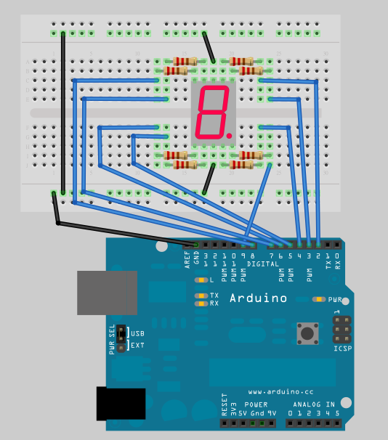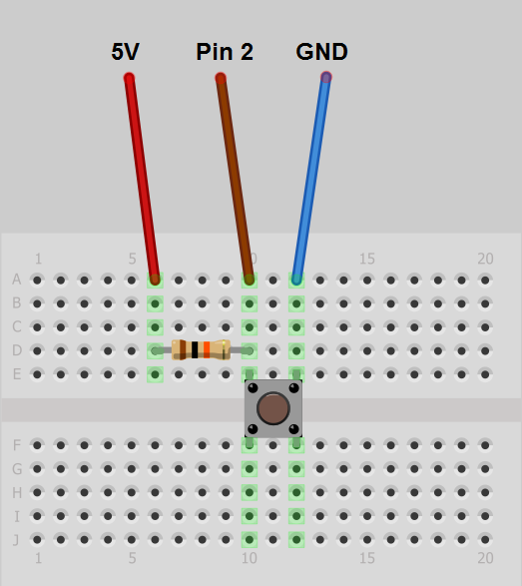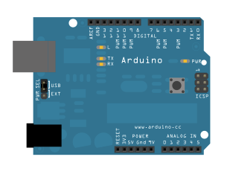

Attach your code and circuit (photo):

:

*/\**

*\*This lab is to use one 1k Ω resistor, one push-button,*

*\*eight 1k Ω resistors, one 7-Segment display,*

*\*and one Aruduino platform to implement LED marquee.*

*\*The function is as follows.*

*\*When push-button is pressed, turn all LEDs of 7-segment on.*

*\*When push-button is released, it show LED marquee.*

*\**

*\*The circuit:*

*\*The pin assignments between 7-Segment and Arduino is as follows.*

*\*(Remember to connect a 220 current-limit resistor between LED of 7-Segment and Arduino pin.)*

*\*7-segment A B C D E F G DP*

*\*Arduino 13 12 11 10 9 8 7 6*

*\*pushbutton attached to 1K resistor from +5V*

*\**

*\*/*

byte pinA=13, pinB=12, pinC=11, pinD=10, pinE=9, pinF=8, pinG=7, pinP=6;

byte pushButton = 2;

*void* setup() {

    pinMode(pinA, OUTPUT); pinMode(pinB, OUTPUT); pinMode(pinC, OUTPUT);

    pinMode(pinD, OUTPUT); pinMode(pinE, OUTPUT); pinMode(pinF, OUTPUT);

    pinMode(pinG, OUTPUT); pinMode(pinP, OUTPUT);

    pinMode(pushButton, INPUT);

}

*// show thespecifiedLEDsof7-segment*

*void* showSevenSeg(byte *A*, byte *B*, byte *C*, byte *D*, byte *E*, byte *F*, byte *G*, byte *P*){

    digitalWrite(pinA, A); digitalWrite(pinB, B); digitalWrite(pinC, C); digitalWrite(pinD, D); digitalWrite(pinE, E); digitalWrite(pinF, F); digitalWrite(pinG, G); digitalWrite(pinP, P);

}

*void* showSevenSeg(*char* *chr*)

{

    if(chr == '0')         showSevenSeg(1, 1, 1, 1, 1, 1, 0, 0);

    else if(chr == '1')    showSevenSeg(0, 1, 1, 0, 0, 0, 0, 0);

    else if(chr == '2')    showSevenSeg(1, 1, 0, 1, 1, 0, 1, 0);

    else if(chr == '3')    showSevenSeg(1, 1, 1, 1, 0, 0, 1, 0);

    else if(chr == '4')    showSevenSeg(0, 1, 1, 0, 0, 1, 1, 0);

    else if(chr == '5')    showSevenSeg(1, 0, 1, 1, 0, 1, 1, 0);

    else if(chr == '6')    showSevenSeg(1, 0, 1, 1, 1, 1, 1, 0);

    else if(chr == '7')    showSevenSeg(1, 1, 1, 0, 0, 0, 0, 0);

    else if(chr == '8')    showSevenSeg(1, 1, 1, 1, 1, 1, 1, 0);

    else if(chr == '9')    showSevenSeg(1, 1, 1, 1, 0, 1, 1, 0);

}

*void* showSevenSeg(*int* *num*)

{

    showSevenSeg(*char*('0' + num));

}

*void* loop() {

*// read the input pin:*

*int* buttonState = digitalRead(pushButton);

    if(buttonState == LOW) {

*// write 109611066 to the 7-segment*

        showSevenSeg(1);    delay(500);

        showSevenSeg(0);    delay(500);

        showSevenSeg(9);    delay(500);

        showSevenSeg(6);    delay(500);

        showSevenSeg(1);    delay(500);

        showSevenSeg(1);    delay(500);

        showSevenSeg(0);    delay(500);

        showSevenSeg(6);    delay(500);

        showSevenSeg(6);    delay(500);

    }

    else{

        showSevenSeg(1,1,1,1,1,1,1,1);*// turn all LEDs of 7-segment on.*

        delay(100);

    }

}

